
A BRIEF INTRODUCTION TO DISC PROFILING
Welcome
Whilst it is true that everyone is an individual with a delicate mix of different parts it is also true to say we all have elements of the four main personality traits outlined here.
The strongest side of our personality indicates what we are like most of the time. A comprehensive profile explains how we think and how we are likely to react in a given situation. Understanding this enables us to get the best out of the situation ourselves
Mistakes we all make
The mistake we all make is in thinking that what motivates us should also motivate others. If it doesn't we sell, cajole or push others into seeing things from our point of view. This is often why the "Boss" is thought of as inconsiderate or a poor manager.
There are four elements that make up a DISC profile?
Everyone has all four elements main elements in their profile. The key to DISC profiling is in knowing how much of each makes up a person's profile and thus indicates what their personality is like.

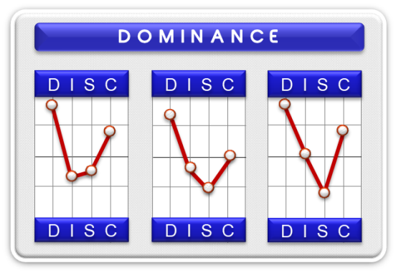
- Dominance – High “D”
Someone with a high degree of Dominance can best be escribed as decisive, logical and competitive. They are very results-oriented with a high activity level, which can make them impatient and intolerant of others who do not move quickly enough. Being popular is not important to the “D”. Being competitive they need a work environment that allows them to gamble their abilities and energy against a win or lose situation. They can have difficulty working as team players because of their impatience and intolerance. The "D" can be a good leader when they are able to control their patience levels.

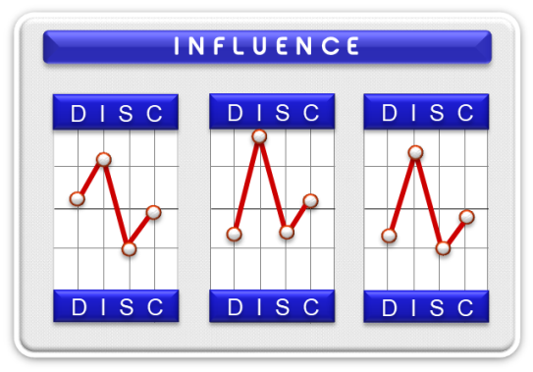
- Influence – “High I”
Influencers are easily recognized by their expressive communication skills. Motivated by independence of action, and popularity and with good verbal skills, they enjoy meeting people, exploring new ideas and developing new concepts.

They enjoy variety and have little fear of meeting new people. Conversations are very easy to them.

They are motivated to achieve success and can be good motivators of other people. They are warm and empathetic regarding the needs of others.
Their impulsiveness coupled with their desire to serve everyone's needs often means they lack good administration skills.

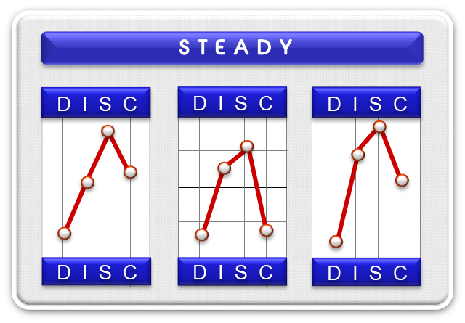
- Steadiness - High S
High S people are thinkers being both analytical and introspective. They rely upon structure and procedures to complete job duties.
Their activity level is even-paced and consistent. Things must be analysed and thought through before any decision can be made. Making the right decision is much more important than pleasing others.
How well the job is done is always more important than how quickly it can be done. They typically avoid close personal relationships. Security and order motivate them. Others describe them as quiet, logical, thorough, reserved, accurate and deliberate.
They can follow a specific and often complex routine that demands thorough analysis. Decisions are made objectively without being influenced by others.

Job changes are few and far between. Security is much more important than other needs. As a result, they are dependable and consistent in their work effort, self-disciplined and methodical. They are organized and efficient in their efforts to complete a job.
Though thinkers are self-disciplined and efficient, they have difficulty setting priorities. They can get lost in the analysis at times and are unable to meet pressured deadlines. They lack the ability to be decisive at times. In addition, they would rather listen than talk.

They are even-paced, consistent and predictable with a high degree of patience

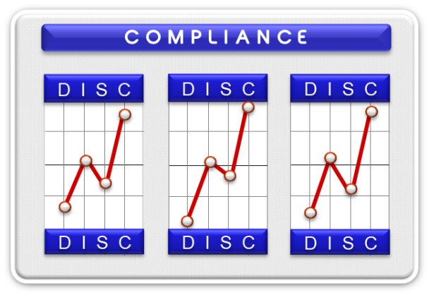
- Compliance - High C
Compliant people often find it difficult to manage their time when they are constantly being interrupted by the needs of others who depend upon them. Their inability to say no at times puts them into situations that inevitably produce stress and anxiety. Their even-paced, highly predictable work effort also causes problems when speed of production is more important than quality of production. They are stressed when others demand change without giving them significant warning

In conclusion it is quite probable that you recognize yourself amongst the above descriptions,
whilst at the same time see parts of yourself in other descriptions. The important thing to
understand is that the main aspect of someone's personality is usually obvious to you and
to the people around you.

